JG-2019 09 10

**SOW Objectives**

**(as explained in Odds maker app and Trading filter frame work attachments)**

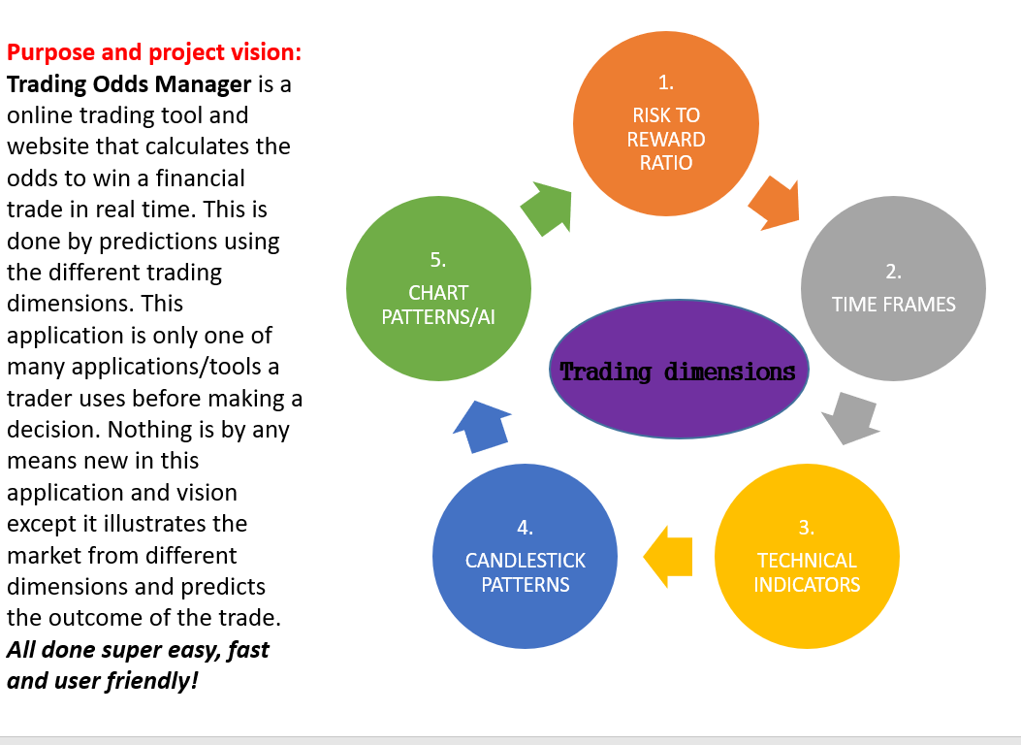

**INDEX:**

**RISK TO REWARD DIMENSION / TIME FRAMES DIMENSION Page: 2**

**TECHNICAL INDICATORS DIMENSION Page: 3**

**CANDLESTICK/PRICE BAR PATTERNS INDICATORS DIMENSION Page: 4**

**CHART PATTERNS DIMENSION Page: 4**

**PART 2: CHART PATTERNS DIMENSION MACHINE LEARNING Page: 4**

**TRADING FILTER Page: 5-6**

**TRADING LAB & MISC Page: 7**

**RISK TO REWARD DIMENSION / TIME FRAMES DIMENSION**

**Page 4 in Odds maker attachment**

***”Your assignment:***

*Create a calculation application that will answer the following question:*

*What is the best risk to reward ratio for the asset and time frame you are about to trade - based on historical data? The app will calculate in real time best buy and sell risk to reward strategy and win ratio for the asset and time frame.”*

1. We would like to have a button/option named ”Risk to Reward” to the right, beside ”Chart pattern” symbol above chart.
2. Pressing it/activating, it will show forecast from last price where you would have target and where you would place stoploss. Default is **6 months** backtest and **Buy**. Both parameters can be changed to ”**X Months**” and ”**Sell**”

**Illustration for Buy:**

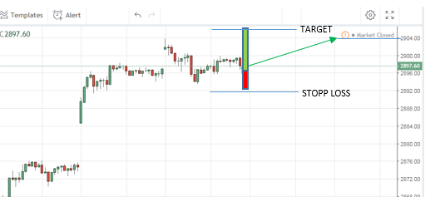

**TECHNICAL INDICATORS DIMENSION**

**Page 5-6 in Odds maker attachment**

***”Your assignment:***

*Create a calculation application for indicators (****in this assignment up to 66 different indicators****) that will answer the following question: When trading an asset what is the most profitable setting for this technical indicator and time frame - based on historical data?*

***Important Note****: Some indicators have more then one way to trigger a signal for buy/sell! (all must be considered/tested)”*

1. For every indicator we have a ”gear” symbol where you can change parameters/color and so forth. Beside the ”Input” symbol we would like to have a ”**Trade signal”** option. This is where the user selects how he wants the indicator to generate buy/sell signals and show them on chart.

Now, most Indicator use value and you might ask: ”How do you get buy/sell signals from a value indicator? Easy, by setting value buy/sell valuepoints! OR if applicable going from + to – value, crossing the so called ”**zero-line**”.

1. Under **”Trade Signal”** there will also a ”**Optimal setting**”. Here you would be presented the optimal setting for the trade signal you have selected based on historical data. Default 6 Months but can be changed.

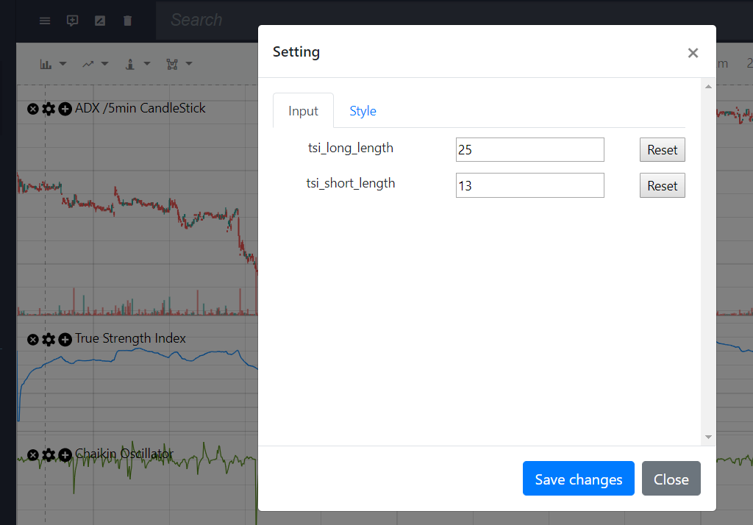

**CANDLESTICK/PRICE BAR PATTERNS INDICATORS DIMENSION**

**Page 8 in Odds maker attachment**

***”Your assignment:***

*Create a calculation application that calculate the win ratio and optimal risk to reward setting for that candlestick pattern and time frame and asset - based on historical data”*

1. Add missing patterns to the library.
2. Calculate the best ”**risk to ”reward”** to trade the pattern for that asset and time frame

**CHART PATTERNS DIMENSION**

**Page 9 in Odds maker attachment**

***”Your assignment:***

*Create a calculation application that calculate the win ratio and optimal risk to reward setting for that chart pattern and time frame and asset - based on historical data”*

1. Add missing patterns to the library.
2. Calculate the best ”**risk to ”reward”** to trade the pattern for that asset and time frame

**PART 2: CHART PATTERNS DIMENSION MACHINE LEARNING**

**Page 10 in Odds maker attachment**

***”Your assignment:***

*Create prediction models that in realtime predicts future movements with atleast 65% accuaracy/win rate!*

*Store them in our AI-library”*

* **This is where you will shine and show us why you are the one for future developments.**
* **Show us your ideas and prediction models**

## TRADING FILTER

**Page: Trading filter frame work attachment**

Do I wish to **buy**/go **long** and hope market raises **OR** do I wish to **sell/short** the asset if we expect the market to go down?

## User Indicator programming and backtesting

Basics understanding of an Indicator, it can only be in 2 states:

* **Active** – Indicator is signaling to **ENTER the market (long/short) or hold trade position.**
* **No signal** – Indicator is not signaling any direction or signaling to **EXIT an ongoing trade**.

With the basics known, the user can now define and program how he wants our application to calculate all the indicators to **ENTER**, **HOLD** and **EXIT** strategies in the steps below:

## Step 1 Select INDICATORS for strategy testing

A user selects his favorite indicators from our library, he can mix them freely from:

* **Technical indicator**
* **Price bars patterns indicator**
* **Chart patterns indicator**

## Step 2 Optimization and Signal selection - Open for GUI solutions/designs!

Once a user has his 1-10 indicators up on dashboard, he then proceeds to configure and program the simulation. He first select signal and optimization for each indicator:

* If the indicator have more than one method to indicate a buy or sell signal the user will select the one he is interested in. ***Otherwise there will be no signal option*** ***since there is only one***
* User can then select to optimize the parameters if it´s possible for that timeframe going back 1,3 6 months of historical data
* User can also manually select parameters for indicator.
* Save settings

## Step 3 Define ENTER signal

Once user have his 1-10 indicators up on dashboard he then proceeds to define which trades he is interested in:

* Buy/long **and** Sell/short signals (Default setting, meaning all trade signals available)
* Buy/long only signals. (Ignore sell/short signals)
* Sell/short only signals (Ignore buy/long signals)

## Step 4 Activation or HOLD position period

Once the indicator has made a ENTER signal the user now defines the conditions for **each** Indicator to hold an Active state or position.

* Indicator Active until indicator switch to opposite buy/sell signal (Default setting)
* Indicator Active until the indicator change direction
* Indicator active until certain price change in percent or value.*
* Indicator active during x amount of price bars or time in minutes*

**\*IMPORTANT** Exit signal will be when we hit Price or Time target **or** Exit parameters in **Part 6** are meet, **whichever comes first!**

**Step 5 User programming, define attribute (Regular, Master or Slave) of indicators and ENTER the market when conditions are meet:**

1. **Regular** - Enter market when all **Regular** indicators are active and indicate same trade direction. (**Default setting**)
2. **Master**- Enter market if this indicator is active independent of all other **Regular/Slave** indicator statuses and directions.
3. **Slave** - Enter market if thisindicator and all other **Regular/Slave indicators** are active, Or Enter market if all other **Regular/Slave** indicators are active even if this indicator is not active

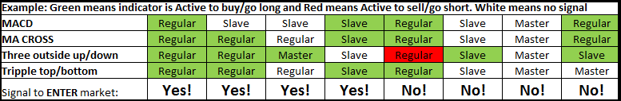

**Step 6 Programming, EXIT the market when all indicators are:**

1. **Regular** - Exit market when all **Regular** indicators are no longer active or has changed signal side, see last YES example where a buy/long position gets an EXIT signal because one indicator has already changed side to a sell/short active (***Default setting***)
2. **Master**- Exit market if this indicator is no longer active, independent of all other **Regular/Slave** indicator statuses.
3. **Slave** - Exit market if thisindicator and all other **Regular/Slave indicators** are not active or has changed signal side, Or Exit market if all other **Regular/Slave** indicators are no longer active even if this indicator is not active.

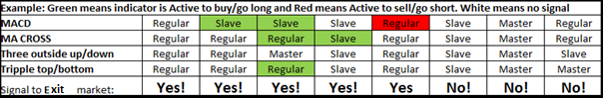

**Trading lab will of course calculate trading statistics one user has run its simulations:**

**Trading lab statistics:**

Best risk to reward Target +2.28% / Stop loss -1.29% *

Win/loss ratio: 63% (252 wins/148 loss)

Max losing streak: 9 losses in a row

Max winning streak: 8 wins in a row

Average time for buy signal: 15 bars (30 hours)

Average time for sell signal: 12 bars (24 hours)

Average profit: 2.12% (217 USD at current price)

Average loss: 1.82% (185 USD at current price)

**TRADING LAB & MISC.**

**Page 11–23 in Odds maker attachment**

**You have experiance in this field so lets have an dialog about features and functionalities**

Key objectives:

* Display data and indicator in a user friendly manner!
* Login features
* Payment options
* API towards IG and more brokers/ Financial data stream